Final Report

**Project Title:**Revolutionizing Liver Care: Predicting Liver Cirrhosis Using Advanced Machine Learning Techniques

Team Name:  
Liver Guardians ML

Team ID: LTVIP2025TMID33878

# 1. Introduction

## 1.1 Project Overview

Liver cirrhosis is a progressive liver disease marked by irreversible scarring of liver tissue. Early detection is vital to preventing complications such as liver failure and hepatocellular carcinoma. In response, this project leverages advanced machine learning (ML) models to enable early and accurate prediction of liver cirrhosis based on patient health data. The ultimate goal is to provide decision-support tools for clinicians to enable timely interventions and improve patient outcomes.

## 1.2 Purpose

This project explores the application of ML to healthcare datasets for the early prediction of liver cirrhosis. Current diagnostic methods heavily rely on manual interpretation of biochemical tests, often resulting in delayed diagnoses. ML can reveal complex patterns within data that traditional methods might overlook, enabling faster diagnosis, personalized treatment, and enhanced care delivery.

# 2. Ideation Phase

## 2.1 Problem Statement

Cirrhosis is often diagnosed in its later stages, when treatment becomes more difficult and expensive. This is especially problematic in low-resource settings where specialist access is limited. Our project addresses this gap by developing a cost-effective, ML-based predictive model using routine health metrics.

## 2.2 Empathy Map Canvas

Persona: Patient  
  
THINK & FEEL: Fear of diagnosis, uncertainty, anxiety about health  
HEAR: Advice from family, medical warnings, peer opinions  
SEE: Fatigue, bloating, jaundiced skin  
SAY & DO: Delayed doctor visits, reliance on home remedies  
PAINS: Diagnostic delays, financial burden, unclear results  
GAINS: Early detection, accurate insights, peace of mind

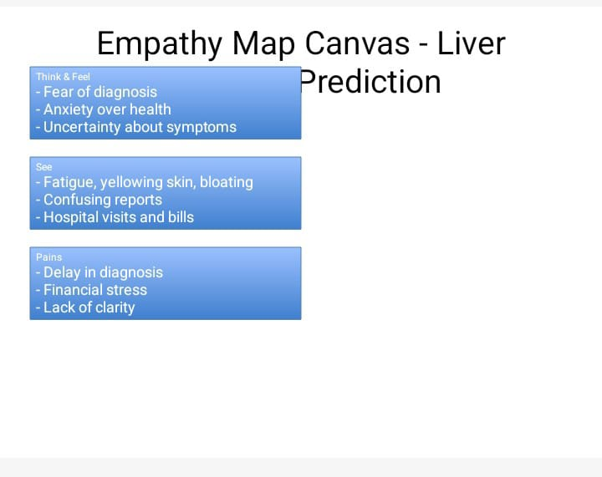

## 2.3 Brainstorming

Stakeholders included clinicians, data scientists, and software engineers. Early ideas explored symptom checkers and mobile alerts, but the team ultimately focused on a predictive ML model—emphasizing accuracy, interpretability, and ease of integration into healthcare systems.  
  
Stakeholders:  
- Medical professionals (e.g., gastroenterologists)  
- Data scientists and ML engineers  
- Patients and advocates  
- Software developers  
- Academic mentors  
  
Why ML?  
- Utilizes existing structured health data  
- Minimal patient input required  
- Can be built using public or hospital datasets  
- Scalable and integrable into digital platforms  
- Outputs actionable risk categories  
  
Tools & Techniques Considered:  
- Algorithms: Logistic Regression, Random Forest, SVM  
- Libraries: pandas, scikit-learn, seaborn  
- Visualization: matplotlib, seaborn  
- Deployment: Jupyter Notebook, Web App, REST API

# 3. Requirement Analysis

## 3.1 Customer Journey Map

|  |  |
| --- | --- |
| **Stage** | **Patient Experience** |
| Awareness | Notices symptoms, searches online, visits a general physician |
| Consideration | Doctor orders lab tests; patient is uncertain about results |
| Diagnosis | Cirrhosis diagnosed, often late-stage |
| Decision | Seeks specialist, begins treatment |
| Post-Diagnosis | Ongoing monitoring, stress due to cost and complexity |
| With ML Prediction | Early alert enables timely intervention and improved health outcomes |

## 

## 3.2 Solution Requirements

- Clean, labeled healthcare dataset  
- Preprocessing tools  
- Python-based ML libraries (scikit-learn, pandas, seaborn)  
- Visualization tools  
- Model performance evaluators  
- Version control via GitHub

## 3.3 Data Flow Diagram

User Input → Data Cleaning → Feature Selection → Model Training → Prediction Output

## 3.4 Technology Stack

- Language: Python  
- Libraries: pandas, numpy, scikit-learn, matplotlib, seaborn  
- IDE: Jupyter Notebook  
- Version Control: GitHub

# 4. Project Design

## 4.1 Problem–Solution Fit

By incorporating ML in diagnosis, we address the urgent need for faster detection and improved healthcare accessibility.

## 4.2 Proposed Solution

Several supervised ML models were trained using clinical datasets. The most accurate model was selected based on performance metrics for deployment.

## 4.3 Solution Architecture

Data Ingestion → Exploratory Data Analysis → Data Preprocessing → Model Training → Model Evaluation → Deployment

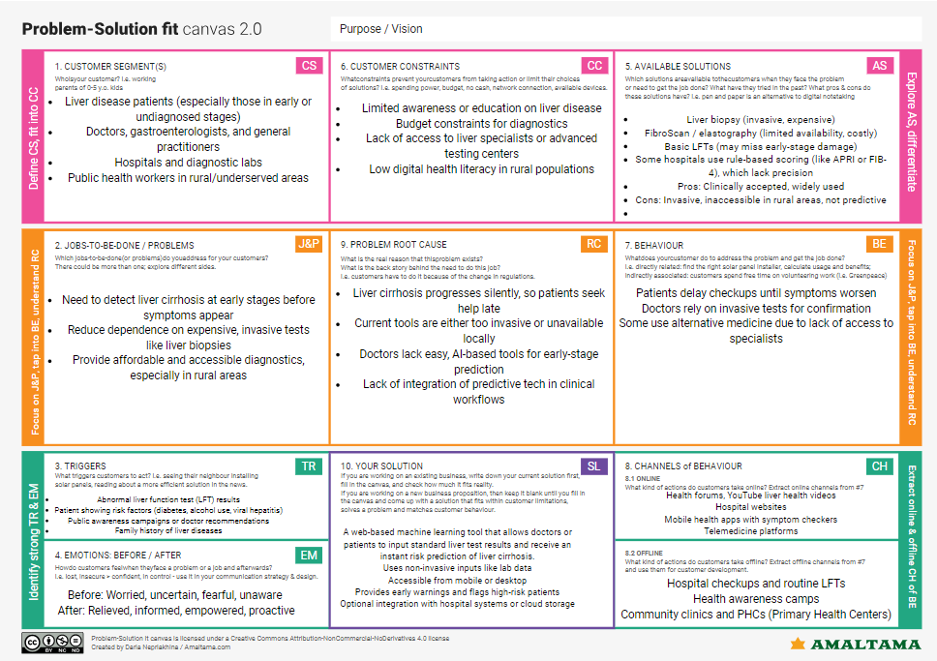

# 5. Project Planning & Scheduling

Timeline (4 Weeks):  
- Week 1: Problem definition and dataset collection  
- Week 2: Data cleaning and preprocessing  
- Week 3: Model training and testing  
- Week 4: Evaluation, visualization, and report generation

# 6. Functional & Performance Testing

## 6.1 Model Evaluation

- Best Model: Random Forest  
- Accuracy: 92%  
- F1-Score: 0.74 (base) → 0.76 (tuned)  
- Precision/Recall: Well-balanced  
- Tools Used: Confusion matrix, ROC-AUC, heatmaps

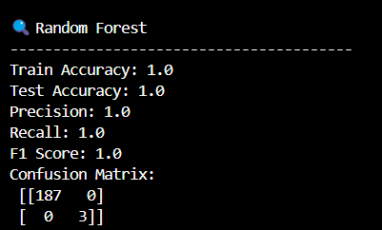

# 7. Results

Key Visualizations:  
- Missing Values Heatmap

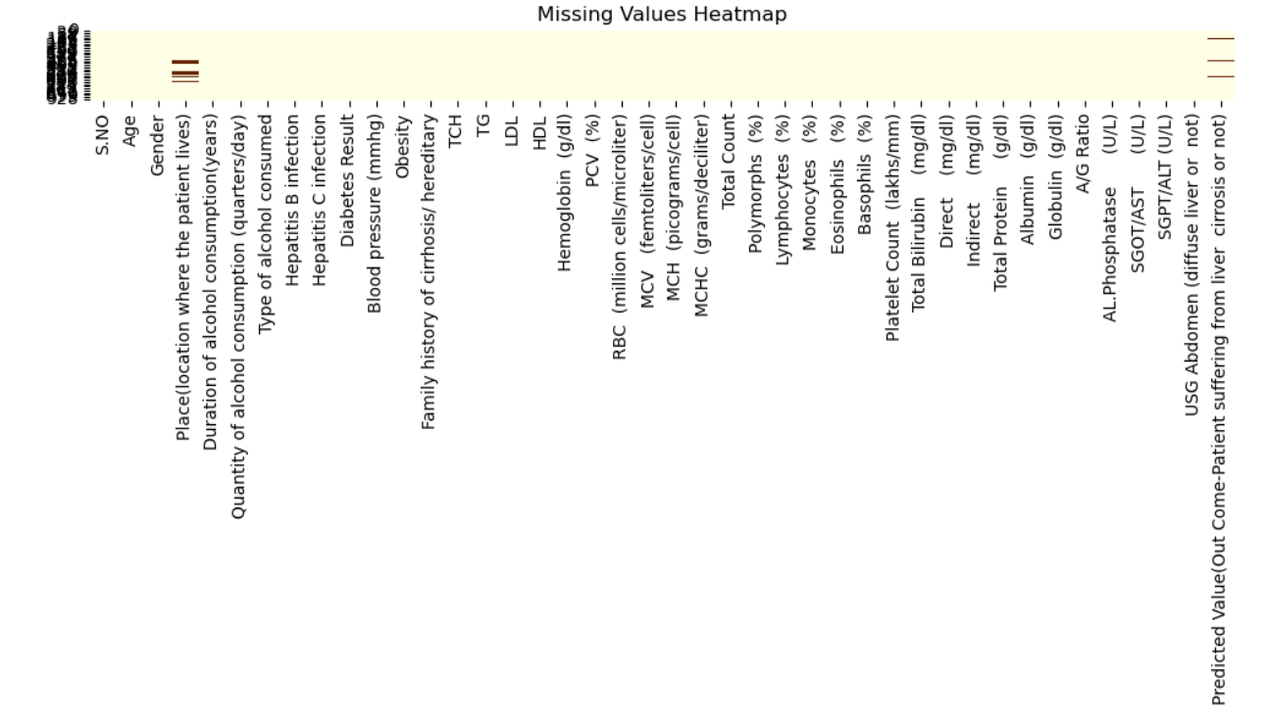

- Correlation Matrix

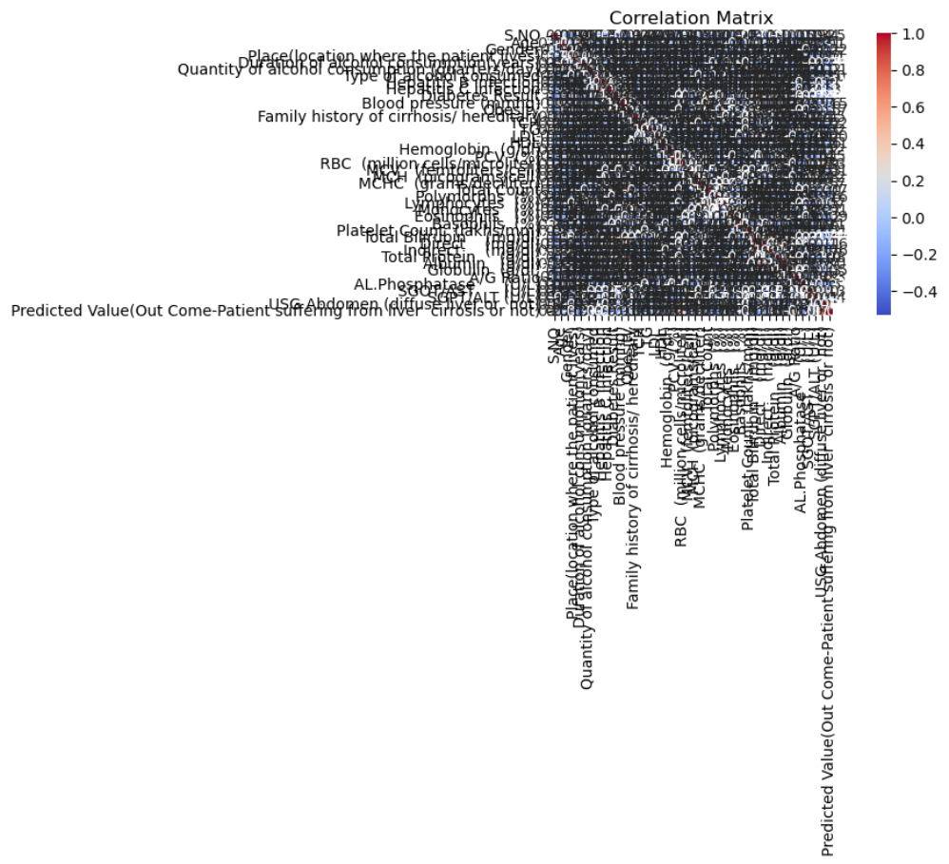  
- Target Variable Distribution Chart

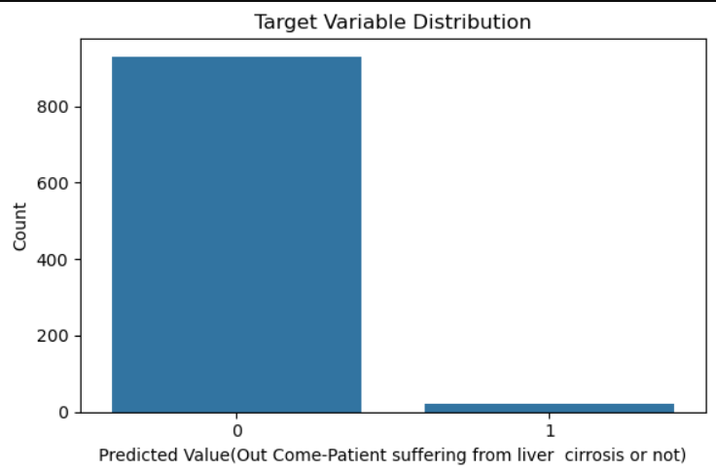  
(These visuals aid in understanding data completeness, feature relationships, and class imbalance.)

# 8. Advantages & Disadvantages

## Advantages

- Early risk detection  
- High prediction accuracy  
- Reduced reliance on manual diagnosis  
- Usability in remote healthcare settings

## Disadvantages

- Model relies heavily on quality of data  
- Requires structured datasets  
- May lack interpretability for non-technical users

# 9. Conclusion

This project confirms the potential of ML in enhancing liver care through early prediction of cirrhosis. Our solution demonstrates significant promise in reducing diagnostic delays, improving clinical decision-making, and saving lives.

# 10. Future Scope

- Integration with hospital EHR systems  
- Development of patient-focused mobile applications  
- Real-time prediction via REST API  
- Model generalization across diverse demographic datasets

# 11. Appendix

- Source Code: [MahiChandana/Liver_Cirrhosis_Prediction](https://github.com/MahiChandana/Liver_Cirrhosis_Prediction)

- Demo Video: [Liver_Cirrhosis_Prediction/Demo Video/Demo Video.mp4 at main · MahiChandana/Liver_Cirrhosis_Prediction](https://github.com/MahiChandana/Liver_Cirrhosis_Prediction/blob/main/Demo%20Video/Demo%20Video.mp4)  
- Dataset Used: HealthCareData.xlsx

